Chapter 5: Bonds
Student Worksheets
A bond is very simply a loan that is represented by an IOU (I owe you).
A bond may be issued by a company or by the government as an alternative form of raising finance. A business may have decided to expand or the government may need it to supplement their tax revenues to pay for vital services and infrastructure.

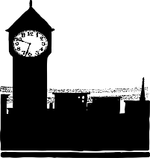
E.g. The UK Government needs to borrow £1 million. They will seek out investors who are willing to lend them this money. In return for the money lent to them, they will issue a BOND. Each bond is a “PROMISE” that you will pay back the bond amount by the maturity date.

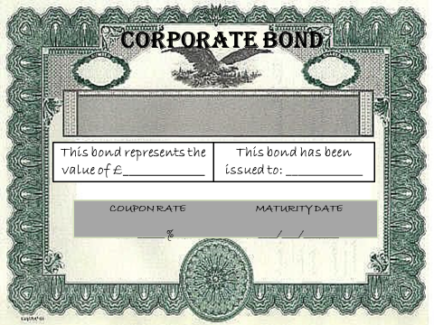
The bond is normally represented by a bond certificate which displays the following:
- The names of the two parties involved.
- The amount that has been lent- this is known as the face value or the nominal value. This is the amount that would be paid back by the bond issuer (borrower)
- The redemption date.
- The coupon rate.

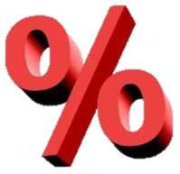
In return for lending them the money, the Government will reward the investors with a coupon rate. This rate is the interest rate that would be earned by the investor on an annual basis.
E.g. If one bond has the value of £1000 and a coupon rate of 5% with a redemption date of five years’ time. Then the investor will receive £50 every year (for five years) as a reward for lending this money.
Bonds can be traded. I.e. if an investor needs their money back earlier and cannot wait until the redemption date, they may decide to sell their bond to another investor. The value at which the bond is traded would be affected by external factors such as the return being earned on other competitive investments.
Case Study: BikeWorld PLC

Sophie has just received £10,000 inheritance after the death of her rich uncle. She is looking to invest this money for a short term and wishes to receive an income from the investment on a regular basis.

BikeWorld Plc is looking to expand their business and requires additional finance. They decide to issue bonds in units of £10,000 promising to pay it back in 6 year’s time at an interest rate of 7% each year (or £700 per annum) to the holder of the bond until it is repaid.

Sophie decides to invest in one £10,000 bond.
Sophie receives a bond certificate which clearly displays:
- The issuer of the bond (BikeWorld Plc)
- The face or nominal value of the bond (£10,000). This can also be known as the ‘par’ value or the ‘principle’. This is the amount upon which interest is calculated and the original value which will be returned to Sophie.
- The maturity or redemption date (6 year’s time). This is the date at which the bond matures and the nominal value of the bond will be paid back to Sophie.
- The coupon rate (7%). This is the annual rate of interest paid to Sophie, based on the nominal value.

What is the benefit to Sophie?
Sophie has benefitted from this investment as she will earn a FIXED RETURN of 7% every year that she holds the bond i.e. £700 every year. She could earn a total of £4,700 if she keeps the bond for the full 6 years (£700 x 6 years = £4,200).
Sophie can look forward to REDEMPTION of the face value of the bond in 6 year’s time, when she will get back her £10,000 in full.

TRADING THE BOND

Sophie has the option to TRADE the bond if she wishes.

  - This means that she can SELL the bond onto another investor without referring back to BikeWorld Ltd.

  - However the trading value/price of the bond may be higher or lower than the nominal value depending on any changes that may have occurred since the original issue of the bond.

  - One year later Sophie is looking for a higher return on her investment, however she still wishes to have the security of regular fixed return. She decides to sell the bond and purchase a different one.

  - In the last two years interest rates have risen significantly above 7%. Sophie is struggling to find an investor willing to pay £10,000, when there are other competitive bonds available on the market, so she decides to lower the price of the bond significantly to £9,000.

  - This entices another investor, George, to invest in this bond, and buy it from Sophie.

  - If George holds the bond until its maturity date, he will get £10,000 back on the redemption date.

  - The difference between the nominal value and the current value of the bond is £10,000 - £9,000 = £1000. This is the compensation George has gained for accepting the uncompetitive 7% coupon.

From this example, we can note the relationship between bond yields, bond prices and interest rates.
Understanding Bond Yields
A bond yield is just another name for “return” and is expressed as an annual percentage.
Yield and coupon are technically not the same thing, as the yield (return on investment) could differ to the coupon rate that was originally stated on the bond certificate.

Impact of Changes in Interest Rates
If a bank increases rates of interest to 10%, then alternative investments may appear to have a more competitive return to the investor as compared to the 7% bond they are already holding.
- Therefore taking the above example, if Sophie wishes to sell her bond, she would have to LOWER the TRADE PRICE of her BikeWorld bond to encourage someone to purchase it.
In contrast, if a bank decreases rates of interest to 4%, then suddenly the BikeWorld bond would appear more attractive as it has already has an agreed coupon rate of 7%.
- In this instance, if Sophie still wanted to sell her bond she could charge a HIGHER TRADE PRICE for her bond.
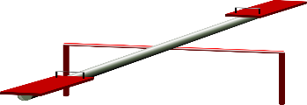
This means there is an inverse relationship between bond price and expected yield:

- When interest rates rise, the trade price of the bond goes down and the expected yield is high.
- When interest rates fall, the trade price of the bond goes up and the expected yield is low.

Worked Example
Yield on BikeWorld Bond when bought by Sophie:
- Nominal value: £10,000
- Coupon Rate: 7%
- Redemption after: 6 years
- Coupon value: £700 per annum
- Yield is the same as the coupon rate.
If held for full 6 years, a total of £4,200 is earned.
Impact of a RISE in Interest Rates
Interest Rates rose to 10% one year later so, Sophie wanted to switch her investment. She decreased the price of the bond so that she could sell it. The yield on the BikeWorld bond when bought by George:

- Nominal value: £10,000
- Coupon Rate: 7%
- Redemption after: there are 5 years remaining
- Coupon value: £700 per annum

However, the bond was bought for £9,000
So the yield is worked out as follows: Coupon Value x 100
Current Price of Bond
Therefore: £700/£9000 x 100 = 7.78%

George has benefited by gaining a higher return on his investment than was originally anticipated.

So, in this instance even though the COUPON RATE is 7%, the YIELD is in fact 7.78%.

- Yield is higher than the coupon rate

What if interest rates had fallen in value?
George decides to sell the bond, as he needs the money for an emergency. When looking at the current interest rates, he notices they have fallen to 4%.
What will be the impact on price of the bond? Will it rise or fall?

The BikeWorld bond, only has 4 years remaining on it. The redemption value is still £10,000. However, the lowering of general interest rates to 4% makes this investment appear more attractive to investors. George can charge a higher price for it. George decides to charge £11,000 as he knows he has a competitive product. This product is bought by Terry.
Calculate the flat yield for this bond and the overall gain for Terry:

KEY TERMS SUMMARY
Bonds are also referred to as: debt instruments, fixed income securities or loan stock.

FLAT YIELD
YIELD = COUPON VALUE x 100
CURRENT PRICE OF BOND

YIELD TO MATURITY
When the calculation includes the capital gain/or loss if the bond is held until its maturity date.
YIELD p/a x No. of years till maturity = Yield to Maturity

NOMINAL VALUE
This is the FACE value of the bond. It is the amount owed by the bond issuer that will be repaid on repayment date.

REPAYMENT/REDEMPTION/MATURITY DATE
This is the date when the full face value of the bond will be paid back to the investor.

TRADEABLE INSTRUMENT
A bond is a tradable instrument which means it can be bought and sold.
Chapter 5: Bonds
Paired Activity: Advantages/Disadvantages of Bonds
Discuss in pairs, the advantages and disadvantages of investing in bonds, and jot down your points in the table below:
ADVANTAGES | DISADVANTAGES

