Chapter 5: Bonds
Activity: Impact on Price of Bonds
Think about whether the bonds will go up or down in value or stay the same?
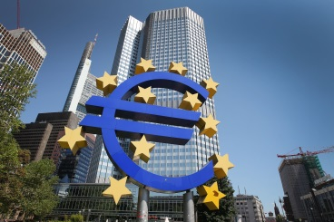 | 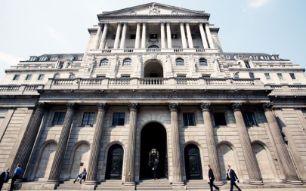
The European Central Bank decreases interest rates in the Eurozone. What is likely to happen to the bond prices of German and French Government Bonds? | The central bank in the UK (Bank of England) increases interest rates.  What will happen to the price of UK government bonds?
Impact on Price of Bond: | Impact on Price of Bond:

In summary, interest rates and bond prices are said to have an inverse relationship – when interest rates in general rise, bond prices tend to fall , and vice versa.
Look at the following three scenarios.
Think about whether the bonds will go up or down in value or stay the same?
Scenario | What will happen to the bond price?
Buddy Inc is an oil exploration company that has just announced a significant discovery of easily accessible oil. What happens to the price of Buddy’s 5% coupon-paying bonds?

Anemone PLC’s sales have suffered due to a recession in its main market. Anemone has a number of 7% coupon-paying bonds in issue – what is likely to happen in their price.

Lakeground Inc announces a substantial equity issue aimed at reducing its debt burden. What is likely to happen to the price of Lakegound’s bonds?

