Chapter 4: Equities
Activity: Dividends Calculations
Enter the formula for calculation dividend yield below:

Complete the dividend yield calculations for the following three companies:
Company Name | Total dividends paid in the last year ($) | Share price ($) | Dividend yield (%)
Abbotts Inc | 4.32 | 172.00
Cyber Inc | 8.64 | 403.00
Xenia Inc | 12.24 | 702.00

Activity: Further Dividend Calculations
Attempt the dividend yield calculations in the questions below, showing how arrived at to your answer. Once completed, attempt the extension questions below.
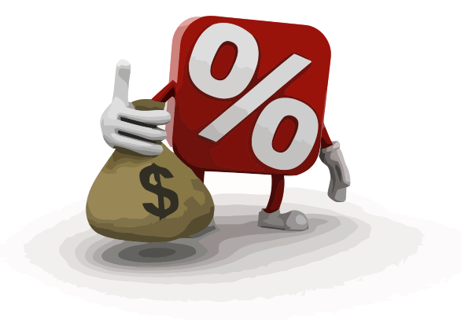
- XYC plc has 38 million ordinary shares trading at £4.50 a share. The company pays out £3 million in dividends. What is the dividend yield?

Answer: ______________

- Zebra plc has issued 27 million ordinary shares, trading at £2.18. The company paid out £4.75 million in dividends. What is the dividend yield?

Answer: ______________

- GOT plc has issued 18 million ordinary shares, trading at £4.61. The company paid out £6.8 million in dividends. What is the dividend yield?

Answer: ______________

- ABC plc has issued 5 million ordinary shares. They were trading at £3.20 a share until warnings that profits had been overstated saw a 15% fall in its share price. The company paid £1 million in dividends. What is the dividend yield?

Answer: ______________

- Pizza D’Actione plc issued 12 million ordinary shares, trading at £5.80. The company paid out £900,000 in dividends to shareholders. What is the dividend yield per share?

Answer: ______________
- Jaytech plc issued 21 million ordinary shares trading at £1.20 until a new CEO was appointed, which saw a share price increase of 55%. The company paid out £6.9 million in dividends. What is the dividend yield per share?

Answer: ______________

Extension:
What could it mean if a company has higher than average yields when compared with the rest of the market?

What could it mean if a company has lower than average yields when compared with the rest of the market?

Summary of Dividends & Capital Gains
Use the table below to summarise the key features of dividends and capital gains.
DIVIDENDS | CAPITAL GAINS

