Activity: Payday Loan Video
- Watch the advert TWICE.
- First time jot down:
What is being advertised?

What does the consumer say is being offered?

- Second time jot down:
The rate of interest being charged

Any other conditions outlined in the “small print” you can see

Be prepared to share your ideas.
Activity: Payday Loans: Are they worth it?
Test out the BBC Monthly Interest Calculator available at the following link:
http://www.bbc.co.uk/consumer/24746198
- Use the online calculator to work out the cost to the borrower of borrowing a loan of £100 for 30 days, at an interest rate of 1987%

Interest charged: £ _____________

How much is being charged for each £1 borrowed? £ _____________

Try out two further calculations and note them below:

- Amount borrowed:
- Duration:
- APR %:
- Interest charged: £

- Amount borrowed:
- Duration:
- APR %:
- Interest charged: £

Thinking Point: Based on this information, do you think that payday loans are of benefit to the borrower? Justify your response.

Stretch & Challenge: Payday Articles Research
Visit The Guardian website. Under the Money Section there is a whole area dedicated to Payday Loans:
http://www.theguardian.com/money/payday-loans
Pick out two interesting news stories that discuss some of the issues associated with the payday loans industry.
Each article should be summarised into 6-10 sentences. You may use the template below to gather your research:
Headline:

Date/Author:

Main Message:

Examples/Evidence

Additional Reading: Payday Loans
How sky-high bank overdraft charges worth 53,000,000% force borrowers into the arms of payday lenders
Ruth Lythe for the Daily Mail
Published: 01:16, 30 January 2013 | Updated: 09:43, 17 April 2013
A Money Mail investigation has revealed how sky-high overdraft charges that are equivalent to an annual interest rate of 53 million per cent are pushing cash-strapped borrowers into the arms of payday lenders.
Bank customers who run out of cash and are forced into the red must pay three times more for borrowing £200 for ten days in a current account than if they had taken a payday loan.
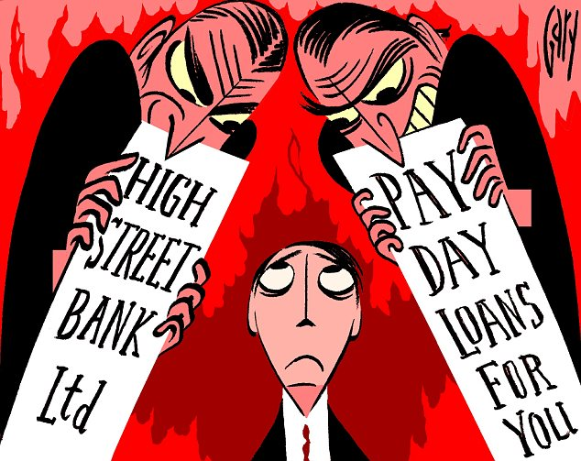
The baffling and expensive charges are forcing many to use alternative lenders — whose up-front fees appear to be clearer and cheaper — but their tactics have been heavily criticised by MPs.

Last week, a report by the Office Of Fair Trading (OFT) revealed how banks are squeezing nearly £2 billion a year from customers who use unauthorised overdrafts.
‘The huge overdraft fees charged by banks mean they are pushing customers out of the frying pan and into the fire of payday lending firms,’ says Laura Willoughby, chief executive of campaign group Move Your Money.
‘The banks are simply not being fair to customers. This utter lack of transparency about charges means people simply don’t have the right information to make the best decisions about their money.’
THE £2 BILLION PROFIT FROM GOING IN THE RED
Up until 2009, overdraft charges were a massive source of profit for the banks.
They would routinely land customers who went a few pence overdrawn with hundreds of pounds of fees. Many could not afford to pay these back.
Money Mail’s Fair Play On Charges campaign led the way in helping borrowers reclaim thousands of pounds.
This stopped when the banks won a legal battle over the fairness of the fees. But in the face of heavy criticism from their own customers they were forced to change the way they did business.
The OFT estimates that banks are making up to £928 million less a year from overdraft charges. However, this fall in profits has coincided with the rise of payday lenders — who are estimated to make £1.9 billion a year.
And overdraft charges are still a huge money-spinner for the banks.
They made almost £2 billion a year from complex overdraft charges — including £1.3 billion from unauthorised lending and £413 million in bounced payments.
Costs are not everything, and banks must treat you fairly if you run into trouble and are struggling under these debts.
For instance, any charges must be proportionate: you should not be hit with a £50 charge for going 50p overdrawn.
‘The banks have proved time and time again that they cannot be trusted to treat customers fairly, yet the watchdogs who are supposed to be regulating this industry are failing to act,’ says Marc Gander, of the Consumer Action Group, an organisation set up to fight excessive bank charges.
SKY-HIGH COST OF BORROWING £200
To test the cost of borrowing, we assumed someone needed to borrow £200 for ten days. After this time, they paid off the debt in full.
We compared High Street bank charges for taking this as an unauthorised overdraft with the cost of using a payday loan company and taking out cash on a credit card.
To give everyone a level playing field we looked at the total cost in pounds and pence and the annual percentage rate (APR) calculation imposed on loan companies by the Office Of Fair Trading.
This figure shows the cost of borrowing if the pattern continued for a full year. In many ways it is unrealistic, as fees and charges from payday lenders and the banks are capped at a certain point.
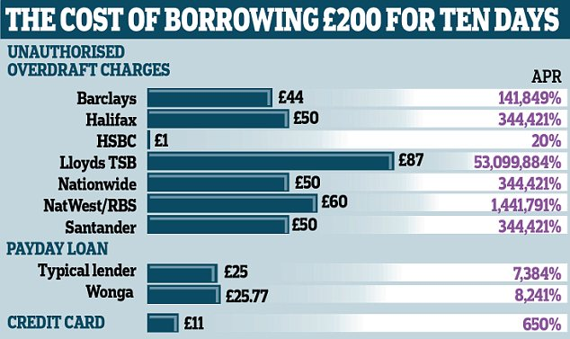
It is impossible for the charges to rack up in this way over a year, but nevertheless it is widely used and endorsed by the OFT.
With a payday loan firm, borrowers typically pay £25 for every £100 they borrow. This cost is based on when they repay the debt — usually when they are next paid.
The cash can be in your bank account 15 minutes after making an application. You can be earning as little as £400 a month to receive the money.
The £25 charge may not sound a lot, but if you were to continue that pattern of borrowing over a year, you would be paying interest typically at a rate of more than 7,000 per cent. If you went to Wonga, the most high-profile payday loan firm, and borrowed £200 for ten days you would have to pay a fee of £25.77 — an APR of 8,241 per cent.
If you miss a repayment, it charges £20; interest is frozen after 60 days.
It claims fewer than one in ten borrowers fails to repay on time.
Other payday lenders charge roughly the same. One has a fee of £25.10 for borrowing £200 for ten days — an APR of 7,384 per cent. A rival charges £25, which is an APR of 7,263 per cent.
OVERDRAFTS THAT COST A FORTUNE
Banks usually have a flat fee for going overdrawn, plus daily charges and, in two examples, an APR.
Unlike with a payday lender, where fees are paid at the end of the borrowing period, bank customers have their charges added when they receive their next statement. This gives an extra period of grace to pay off the debt as, while the initial borrowing is repaid after ten days, the extra charges do not have to be cleared until the following month.
A customer of Lloyds TSB, which is still partially owned by the taxpayer and is Britain’s largest current account provider, who went £200 into an unplanned overdraft would have built up charges of £87 after ten days.
That is equivalent to an APR of 53,099,884 per cent.
This includes £1 interest, a £6 overdraft usage fee and £10-a-day fees — to a maximum of eight days in any month.
Lloyds says in reality no one would pay this annually. Santander, Halifax and Nationwide’s Flex Direct account all charge £50 for borrowing £200 over ten days. This is equivalent to an APR of 344,421 per cent.
NatWest and RBS will hit you with a £6 a day fee, so a total of £60 over ten days. This means their APR is 1,441,791 per cent.
Barclays charges £22 for going over your overdraft for five working days. Once you’ve gone into the red, you can borrow up to £2,500 without further charge provided you pay it back after five days.
On the sixth day, the £22 charge is applied again. So if you went £200 overdrawn for ten days the fees would be £44.
This is equivalent to interest of 141,849 per cent APR on a £200 overdraft. HSBC charges the cheapest rates on unauthorised overdrafts at 19.9 per cent — meaning you would simply pay £1 for going £200 overdrawn.
However, if you have already gone into the red in the past six months, you will be lumbered with a £25 charge.
Justin Modray, founder of savings website Candid Money, says: ‘The rates being charged by some banks are astounding, although this does also highlight how APR is an inappropriate measure for very short- term borrowing.
‘Nevertheless, despite re-jigging their overdraft charging to be simpler, most banks continue to charge an arm and a leg if you slip into an unauthorised overdraft.’
WHY YOU SHOULD STICK WITH BANKS
The crucial difference between the payday lenders and the banks is that the latter are under a lot of scrutiny from the City regulator.
Their staff are held to account, there are very clear complaints procedures and rules for hard-up customers.
Banks are also regularly forced to explain their actions to the independent complaints body the Financial Ombudsman Service.
Understanding how much your debt will cost when you need money for a short time can be confusing.
However, the banks are at least honest in admitting all their charges.
Many payday lenders will not reveal how quickly fees can balloon if you don’t pay back the money back on time. Often the true cost of late payment is only revealed by ringing up their customer helplines.
For example, one lender boasts on its website that borrowing with it is cheaper than going into the red at the Halifax.
However, if you failed to pay back your loan on time, you would continue to pay interest for every one of the next four fortnights.
After this point, one of its call centre staff told us your debt would be passed on to a collection agency, which will charge you a £350 fee, and your interest will continue to mount. And some payday lenders can be very quick to call in debt collectors if you don’t pay what you owe
PLAN AHEAD TO CUT THE COSTS
Withdrawing cash on a credit card is often condemned by experts as among the most expensive way of borrowing.
This is because you are typically charged a one-off fee for cash withdrawals — as well as a higher rate of interest.
But our investigation revealed how taking out £200 and repaying it after ten days was far cheaper than dipping into your unplanned overdraft, or taking a payday loan.
Even with the most expensive card issued by leading brands, you would be charged a one-off fee of £10 and interest at 27.9 per cent. That is an APR of 650 per cent if you continued this pattern. That is made up of £10, plus £1.35 interest.
You can cut the risk of dipping into your unauthorised overdraft by switching to a bank account designed for borrowers.
For example, Halifax’s Reward account offers an interest-free overdraft for the first year after opening the account.
However, the deal is only open to new customers who apply through its switching service. And your interest jumps to between £1 and £3 a day after a year, depending on the size of your overdraft.
The account also pays £5 in credit interest, but from May you won’t get this cash if you go into your overdraft.
Alternatively, First Direct’s 1st Account will give you £250 interest-free. After this, you will pay 15.9 per cent.
If your bank has hit you with unfair charges you can ask for them to be refunded or for the bank to ease your financial burden. The bank should listen, particularly if you plead hardship. If they don’t, turn to the Financial Ombudsman Service, financial-ombudsman.org.uk or 0800 023 4567.
Or you can take your bank through the Small Claims Court under the little-known Banking Conduct Of Business rules — although this is not yet a very tried or tested route.
A spokesman from trade body the British Bankers’ Association says: ‘Charges for unarranged overdrafts have dropped substantially.
‘Banks recognise that on occasion we can all be faced with unexpected expenditure; overdrafts can be a good way to help customers. Equally, going overdrawn without arranging an overdraft — or exceeding an overdraft limit — could be an early indicator of other financial problems which, if addressed quickly, can be minimised or avoided altogether.
‘Bank fees are fully transparent: not only are these all publicly available, but also banks post scenarios on their websites so potential customers can see how they work in practice. And existing customers also receive annual statements that show clearly what they have paid for the services they received over the year.’
JUSTIFYING THE CHARGES
A Lloyds TSB spokesman says the bank would contact customers who spend outside of unplanned overdraft limits.
‘An unplanned overdraft is not designed for long-term borrowing and the vast majority of our customers don’t use their overdraft facility in an average month — those that do only go overdrawn for a few days, usually at the end of the month.
‘Customers who operate outside agreed limits will be contacted to discuss the options available to them to assist in repaying the debt. Where necessary, fees and charges are reviewed to support the customer’s return to order.’
A Barclays spokesman says it would be ‘unrealistic’ and ‘impossible’ for a customer to use the bank’s emergency overdraft facility — which it calls its Personal Reserve — over the course of a year. He says the bank would be in touch early with customers who were in this situation.
‘Barclays Personal Reserve is unlike any other service offered by financial organisations as it provides customers with the option of an instant, transparent, pre-agreed emergency overdraft for occasional short-term use, with the certainty that payments will be made within the limit of the Reserve.
‘It is designed for very occasional short-term use, which makes any APR comparisons to other, longer-term, less flexible borrowing options erroneous.’
A Nationwide spokesman said APR calculations were not ‘credible’ when used with flat-fee sums.
‘An individual cannot choose to borrow on an unarranged overdraft. An unarranged overdraft occurs when someone breaks the terms and conditions of their account. The charge is made when the terms and conditions of the account have been broken.
‘A customer can choose to opt for a payday loan and that is agreed borrowing, rather than unarranged borrowing.’
An HSBC spokesman says: ‘We do not charge a fee for small or infrequent moves into an informal overdraft or at all for those requesting a formal overdraft. Clearly, if a customer knows that they are going to need to be in their overdraft repeatedly they should arrange a formal overdraft for an adequate limit.’
And Santander says: ‘Unarranged overdrafts are not used for long-term lending, therefore the APR suggested is not reflective or comparable. Where customers require longer-term borrowing, they can discuss alternative forms of arranged borrowing, such as an agreed overdraft or a personal loan.
Our overdraft tariff is designed to be clear and transparent and in addition we also offer free services to help customers stay in touch with their banking.’
RBS had not responded by the time Money Mail went to print.
Adapted from: http://www.thisismoney.co.uk/money/saving/article-2270230/How-sky-high-bank-overdraft-charges-force-borrowers-use-payday-lenders.html#ixzz3yWy91fiX

