high net worth individuals own 38% of uk’s total wealth, report says
Sean Farrell
Wednesday 28 January 2015 21.38 GMT

Number of dollar millionaires predicted to hit 1m within three years
Britain is home to 840,000 people who are dollar millionaires with £660,000 or more excluding their main home – a combined wealth of $3.5tn (£2.3tn).
The number of high-net-worth individuals (HNWIs owning at least $1m) declined by 1.2% from the end of 2007 to the end of 2013 as financial crisis turned to recession, but it is now expected to reach 1 million in the next three years, the report by New World Wealth said.
Falling equity and property prices over the six years cut the total number of HNWIs by about 10,000, although the number of billionaires and those with $100m or more increased as rich people from abroad came to Britain.
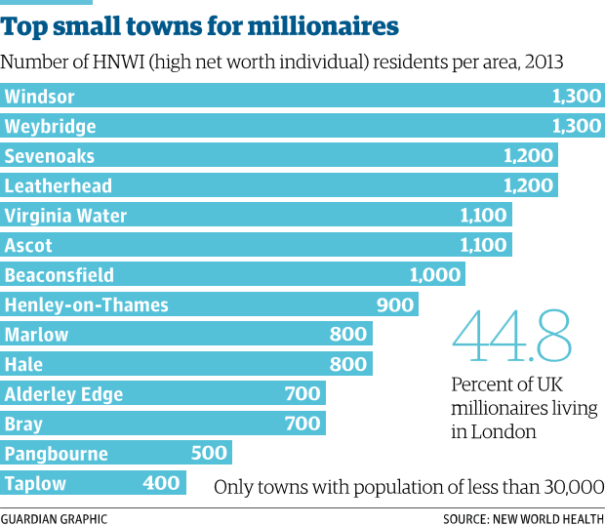
“This decline would have been far greater had it not been for the migration of a large number of wealthy individuals into the UK during the period,” said the report.
“We estimate that over 30,000 HNWIs moved to the UK during the review period. The bulk … came from the EU, Asia and the Middle East. Most of them settled in London and south-east England.”
While HNWIs’ total wealth declined between 2007 to 2013 by 0.9%, UK GDP per head fell much more steeply, losing 16%.
The share of the UK’s total wealth owned by HNWIs is now 38%, compared with the worldwide average of 34%.
London is home to most of Britain’s wealthy, with 376,600 HNWI residents, or 44.8% of the UK total.
But despite London’s status as a haven for the world’s wealthy, Edinburgh, Scotland’s financial centre, has a higher concentration of HNWIs than the capital.
HNWIs make up 5.8% of Edinburgh residents, compared with 4.5% for London and Manchester.
London and the south-east’s dominance of the nation’s wealth is underlined by rankings for the top counties for millionaires. The capital and surrounding counties such as Surrey, Kent and Hertfordshire make up seven of the top 10, with Greater Manchester, Edinburgh and Lancashire the others.
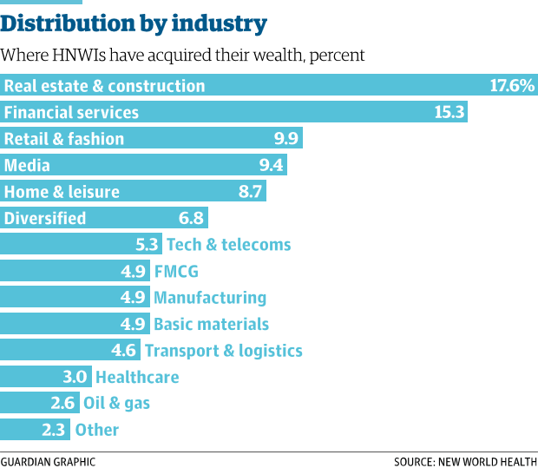
The home counties include nine of the top 10 small towns for millionaires. The top three are Windsor in Berkshire, Weybridge in Surrey and Sevenoaks in Kent. Hale in Greater Manchester was number 10 and Alderley Edge, Cheshire, was 11.
Britain, including the Channel Islands, is the third biggest HNWI market in the world, behind the US and Japan.
Real estate and construction is the main source of wealth for 18% of UK HNWIs, ahead of financial services (15%), retail (10%) and media (9%).
So-called core millionaires, with assets of up to $30m (£20m), make up 64% of UK HNWI wealth. The number of “ultra-high-net-worth individuals”, with assets of $30m or more, fell 0.2% from 2007 to 2013, but the number of billionaires rose by a third, to 102. Those with $100m or more increased by 8%.
The years since the financial crisis have been marked by rich people from abroad buying property in the UK for investment or basing themselves in London.
Rich foreigners helped fuel a 30% increase, to $15bn, in spending on luxury goods such as cars, clothing and hotels from 2007 to 2013, more than offsetting the decline in overall HNWI numbers.
http://www.theguardian.com/business/2015/jan/28/high-net-worth-individuals-uk-wealth-report
Summary Questions
- How has the number of HNWI’s in the UK changed between 2007 and 2013?
- Identify and explain two reasons for this change.
- What percentage of UK millionaires, live in London?
- What are the three top towns where millionaires are residing?
- What is the main source of millionaires’ wealth?
- What do you think has attracted rich foreigners to move to the UK and particularly London? Where have the majority of these millionaires come from?

