Activity: Financing Choices
Complete the following table to compare borrowing against equity to raise finance. Give reasons for your choices.
Consideration | Borrowing or Equity?
Which one is more expensive (in terms of annual cash costs)? | Borrowing or Equity:  REASON:
Which one is likely to need to be repaid earlier? | Borrowing or Equity:  REASON:
Which one is more likely to be available for a start-up company? | Borrowing or Equity:  REASON:
Which one is likely to be the more risky for the finance provider? | Borrowing or Equity:  REASON:
Which one is likely to be most advantageous to the finance provider? | Borrowing or Equity:  REASON:

Thinking point: Why might a business choose to use equity, rather than borrowing to raise finance for projects?

Activity: Barclays Video on Risk and Reward
Watch the video clip by Barclays and answer the following questions:
- Why do individuals choose to invest?

- What are the factors to consider when planning to invest? Why is it important to consider these factors? Use the mind-map below to document what you hear:

FACTORS TO CONSIDER

- What is the balance between risk and reward individuals must weigh up?

Activity: Risk and Reward
Put the following investments in order, from most risky (and potentially rewarding) to the least risky (and safer).
Investments | Risk Ranking  (where 1 is the highest risk and 6 is the lowest risk)
US Government Bonds
Equities issued by a start-up company
Equities issued by a large, well-established company
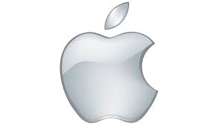
Bonds issued by a large, well-established company
Bank account
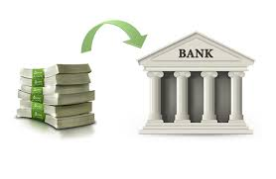
Roulette wheel at a casino

Thinking Point: What conclusions can you draw about investing in equities compared with investing in bonds? Which is more/less risky and why?

