Data Analysis: Who would you generally trust to tell the truth?
Consider each of the graphs 1 – 4 below. What does each one show? What are your conclusions from each graph?
Graph 1
Source: Ipsos MORI Political Monitor, Jan 2015
Graph 1:

Graph 2
Source: Ipsos MORI Political Monitor, Jan 2015
Graph 2:

Graph 3
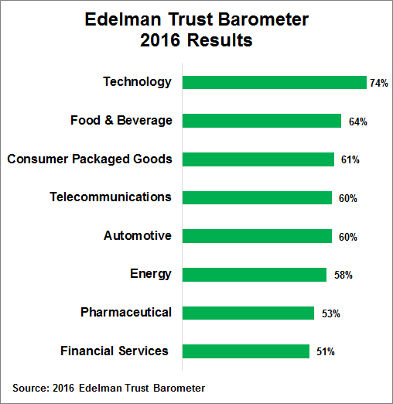
Source: 2016 Edelman Trust Barometer Survey Trust in Financial Services
Graph 3:

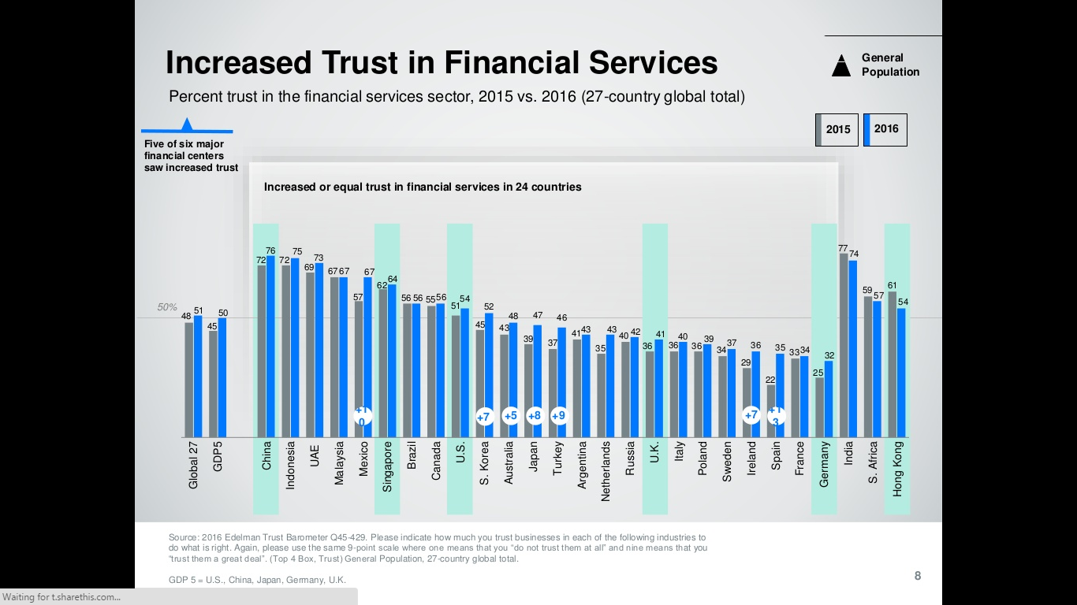
Graph 4
Source: Edelman Trust in Financial Services 2016

Graph 4:

