Exam Bookings (2022-23)

The CISI offers two externally assessed units for delivery in schools and colleges via computer-based exams:

- Level 3 Award for Introduction to Securities & Investment – a standalone professional qualification
- Level 2 Award in Fundamentals of Financial Services – a standalone professional qualification

EXAM DATES:

Computer-based Exams

Exam dates are not set by the CISI for schools and colleges exams where they are assessed via computer-based testing. Centres can determine their own exam dates during the academic year.

Centres must provide at least four-weeks’ notice of an exam booking, prior to the proposed exam date. This allows for an appropriate amount of time to ensure the exam software runs effectively on the centre’s network and any reasonable adjustments are applied for in time to notify Prometric, the third-party exam provider.

Please note that new exam centres will be required to undertake software accreditation to hold exams which can take between 8-12 weeks to complete. This will require support from the school or college Exam and IT Teams.
It is recommended that this process commences at the start of an academic year to ensure there is enough time to sit the exam before the end of the academic year.
Please contact centreoperations@cisi.org to start this process.

Qualification syllabi are updated at the end of July each year. Consequently, learning objectives can be updated and added, which may result in changes to exam questions. Therefore, it is recommended that candidates sit exams in the same academic year in which they are studying towards the qualification.

EXAM BOOKINGS:

Centres must provide at least four-weeks’ notice of the first exam booking being made in the academic year, prior to the proposed exam date.

Exam re-sits will only require three working days’ notice prior to the proposed exam date.

Reasonable Adjustments

Where candidates require a reasonable adjustment for their exam e.g., additional time, the centre should inform the CISI when the exam booking is made (at least four-weeks prior to the exam sitting) and submit a completed Reasonable Adjustment Application Form for each student along with all relevant supporting medical documentation relating to this request.

The CISI will in most cases accept a current completed JCQ Form 8, which has been successfully used to apply for reasonable adjustments with alternative awarding bodies for a candidate.

Reasonable adjustment requests will be sent to the CISI Qualifications Team who will review the request and determine whether it can be approved. The Schools and Colleges team will contact the centre in the event of the request being approved or not.

Please refer to the CISI’s Reasonable Adjustment Policy, which can be found in the ‘Exams Booking’ folder for further details of supporting evidence that may be submitted.

We are unable to accept reasonable adjustment requests any later than four-weeks prior to the exam date.

Making an Exam Booking

For centres that are ‘Surpass’ software accredited, exams can be booked by completing the ‘CISI School and College Exam Booking BLANK’ spreadsheet, which can be found in the ‘Exam Bookings’ (please see screenshot below) folder in the ‘Google Drive’.

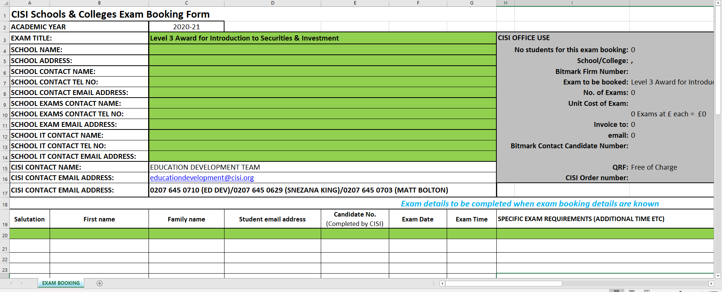

Please complete the spreadsheet by:

- Selecting the relevant exam name that candidates will be sitting
- Adding the details of the school and key contacts requested
- Adding the candidates’ details (incl. candidate number)
- Adding the proposed exam date(s) and time(s)
- Adding any special exam requirements (reasonable adjustments) for candidates, which should be supported by relevant evidence (please see section above on Reasonable Adjustments).

Once the exam booking spreadsheet has been completed, please send this via email to the Schools and Colleges team will acknowledge the exam booking request via email.

CANDIDATE TRANSFERS AND WITHDRAWALS

Transfers

Candidates who wish to transfer their examination need to contact the centre at which they are due to be taking their examination. The school or college is responsible for all transfer arrangements and the costs involved.

The CISI requires at least seven days’ notice to transfer the date of a CBT examination.

Where candidates are booked to sit a CISI CBT examination but fail to attend, if the CISI are not notified by the centre prior to the examination, the full examination fee will be charged to the centre.

Withdrawals

A centre must provide at least seven days’ notice, prior to the exam date if they are seeking to withdraw a candidate from a CISI computer-based exam.

If a centre provides the required notice period to the Education Development Team of a candidate’s withdrawal, a refund of the exam fee will be processed.

If the required notice is not provided by the centre, the centre will not be eligible for a refund of the candidate’s exam fee.

EXAM RESULTS:

Exam results will be sent to the teacher and or exams contact within two working days of the exam being sat.
EXAM RESITS:

Candidates are eligible for one free exam re-sit. As they are professional qualifications, there is not a requirement for centres to submit predicted grades for candidates.

Candidates are also permitted to take the exam on six occasions in a year (with some restrictions). Only the first re-sit is free of charge for each qualification.

Booking an exam re-sit

Centres can book an exam re-sit for eligible candidates with at least three-working days prior to the proposed exam date. Centres should contact the Education Development Team with the names of students who will be re-sitting the exam, along with the date and time of the proposed exam sitting.

